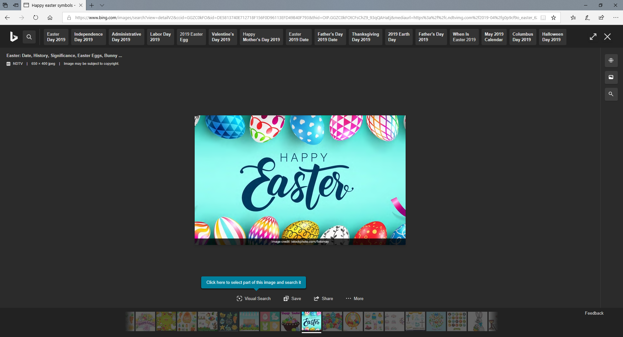

UNIVERSITY STUDENT EASTER

MEMBERSHIP OFFER

One off special – one-month membership for

ONLY £25

For University students that were previous members and are already on our system.

Normal concession rate of £32 applies for those that are non-members that are not on our system.

